**1 FORMA**

>> clear all

>> syms x

>> syms dx

>> syms Xd

>> syms dXd

>> p=(400*x^5 - 900*x^4 + 675*x^3 - 200*x^2 + 25*x + 1/5)*dx;

>> a=0;b=0.8;

>> x=(b+a)/2 +(b-a)*Xd/2;

>> dx=((b-a)/2)*dXd;

>> p=(400*x^5 - 900*x^4 + 675*x^3 - 200*x^2 + 25*x + 1/5)*dx;

>> p=inline(p)

p =

Inline function:

p(Xd,dXd) = dXd.*(Xd.*1.0e1-(Xd.*(2.0./5.0)+2.0./5.0).^2.*2.0e2+(Xd.*(2.0./5.0)+2.0./5.0).^3.*6.75e2-(Xd.*(2.0./5.0)+2.0./5.0).^4.*9.0e2+(Xd.*(2.0./5.0)+2.0./5.0).^5.*4.0e2+5.1e1./5.0).*(2.0./5.0)

>> I=p(-1/sqrt(3),1)+p(1/sqrt(3),1)

I =

1.8226

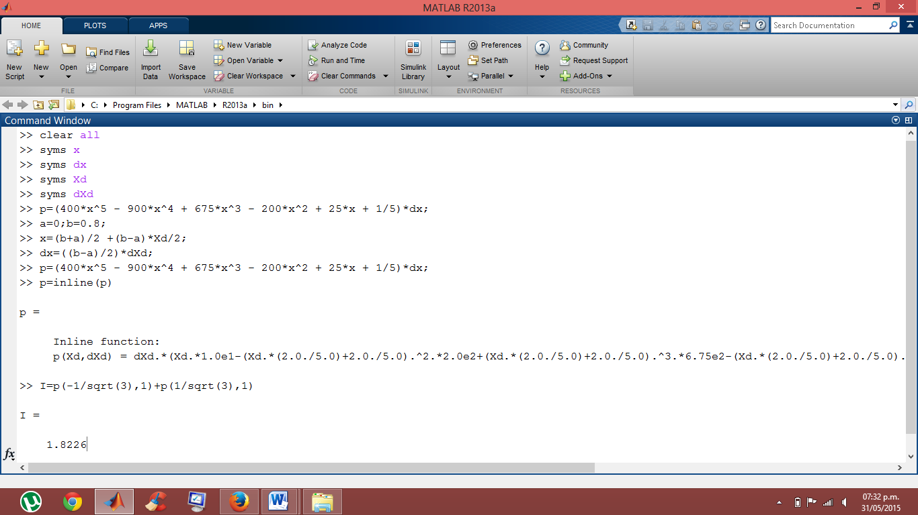

**2 FORMA**

>> clear all

>> syms dx

>> syms Xd

>> syms dXd

>> p =[400 -900 675 -200 25 0.2];

>> p =poly2sym(p);

>> p=p*dx;

>> p=inline(p)

p =

Inline function:

p(dx,x) = dx.*(x.*2.5e1-x.^2.*2.0e2+x.^3.*6.75e2-x.^4.*9.0e2+x.^5.*4.0e2+1.0./5.0)

>> a=0;b=0.8;

>> c0=1;c1=1;x0=-0.577350269;x1=0.577350269;

>> x=(b+a)/2 +(b-a)*Xd/2;

>> dx=((b-a)/2)*dXd;

>> F=p(dx,x);

>> F=inline(F)

F =

Inline function:

F(Xd,dXd) = dXd.*(Xd.*1.0e1-(Xd.*(2.0./5.0)+2.0./5.0).^2.*2.0e2+(Xd.*(2.0./5.0)+2.0./5.0).^3.*6.75e2-(Xd.*(2.0./5.0)+2.0./5.0).^4.*9.0e2+(Xd.*(2.0./5.0)+2.0./5.0).^5.*4.0e2+5.1e1./5.0).*(2.0./5.0)

>> I=c0*F(x0,1)+c1*F(x1,1)

I =

1.822577778020695

COMPILACION

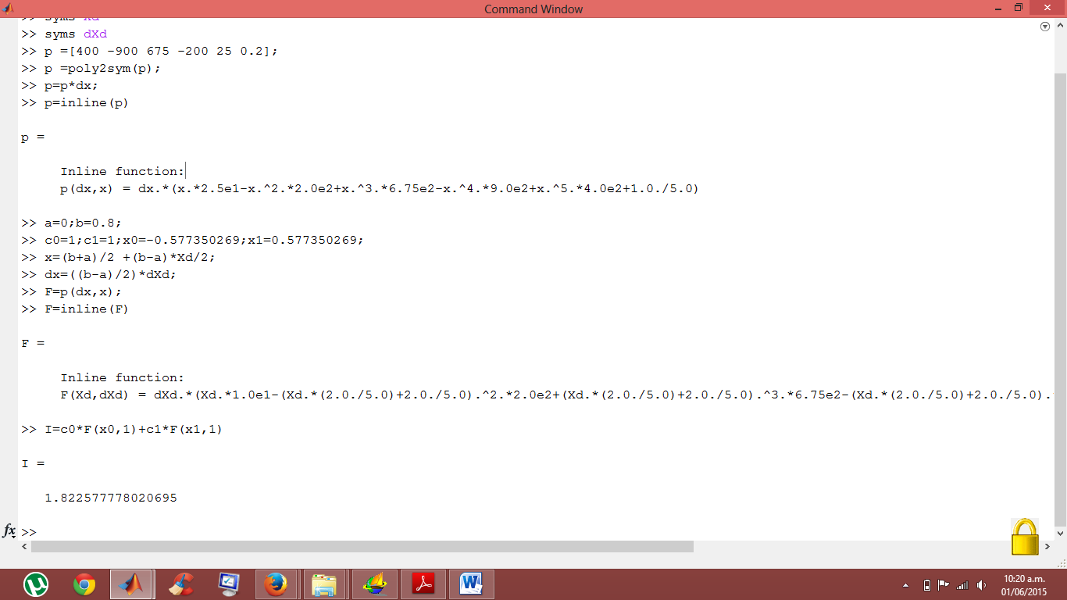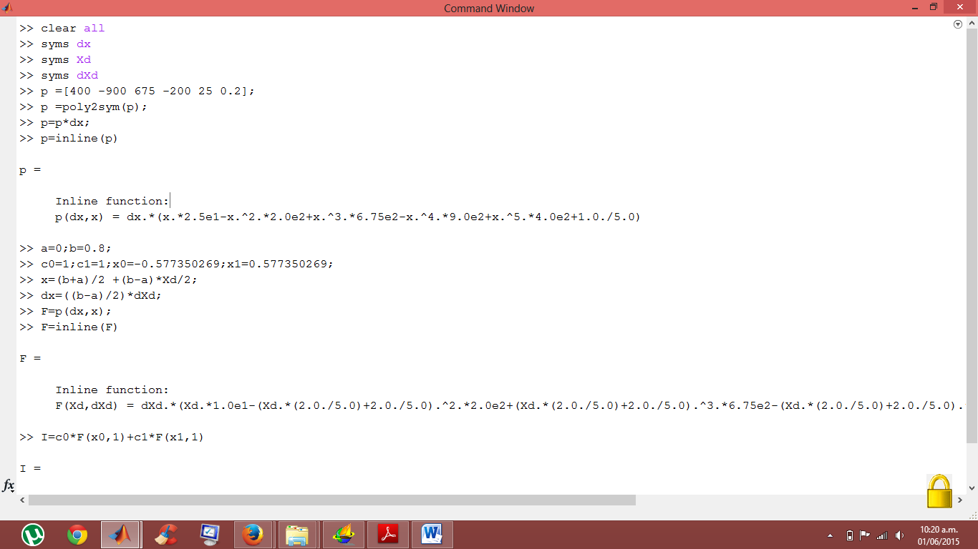

**PARA 3 PUNTOS**

>> clear all

>> syms dx

>> syms Xd

>> syms dXd

>> p =[400 -900 675 -200 25 0.2];

>> p =poly2sym(p);

>> p=p*dx;

>> p=inline(p)

p =

Inline function:

p(dx,x) = dx.*(x.*2.5e1-x.^2.*2.0e2+x.^3.*6.75e2-x.^4.*9.0e2+x.^5.*4.0e2+1.0./5.0)

>> a=0;b=0.8;

>> c0=0.5555556;c1=0.8888889;c2=0.5555556;x0=-0.774596669;x1=0;x2=0.774596669;

>> x=(b+a)/2 +(b-a)*Xd/2;

>> dx=((b-a)/2)*dXd;

>> F=p(dx,x);

>> F=inline(F)

F =

Inline function:

F(Xd,dXd) = dXd.*(Xd.*1.0e1-(Xd.*(2.0./5.0)+2.0./5.0).^2.*2.0e2+(Xd.*(2.0./5.0)+2.0./5.0).^3.*6.75e2-(Xd.*(2.0./5.0)+2.0./5.0).^4.*9.0e2+(Xd.*(2.0./5.0)+2.0./5.0).^5.*4.0e2+5.1e1./5.0).*(2.0./5.0)

>> I=c0*F(x0,1)+c1*F(x1,1)+c2*F(x2,1)

I =

1.640533406089574

COMPILACION:

